Rujiraphat School : Schedule and Information, 2021 academic year

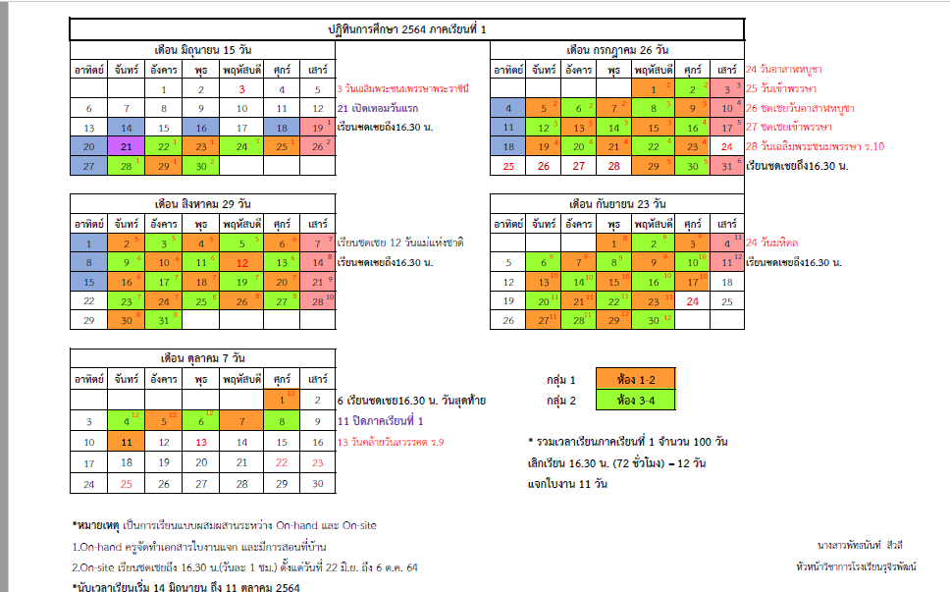
- 1st Semester start on 21 June 2021
- The ORANGE and GREEN highlight: students in each grade be divided into 2 groups ( ORANGE is class 1 and 2 and GREEN class 3nad 4 ) and each group comes to school in alternate day as shown in time table

- In each day: as regularly studying in school the study is 6 hrs/day (from 8:30am to 3:30 pm)
- The PINK highlight shown the EXTRA teaching-learning to compensate the school postpone because of COVID-19 situation (School should open since 1 June 2021) for 12 times. However, to decrease the extra teaching on Saturday (PINK highlight ), school make adjusting teaching by adding one hour in each day (3:30pm-4:30pm, for 6 times to replace 1 day of the PINK highlight) . That means a small number on each day shown the extra of PINK highlight, for example teaching on date 19 JUNE would be adding 1 hr /day on 22-25, 28-29 June 2021)

- The BLUE highlight on each date means on site teaching (distribution lesson by paper based) in the village : teachers and students have made appointment together for 11 times

- For tteachers, they come to school everyday.
++++++++++++++++++++++++++

At present of COVID 19 Situation
- School announcement for school closing on 5-19 July 2021
- Teachers still come to school everyday.
- Teaching will be run through ON-HAND campaign (paper-based, teacher distributing lesson to student directly in the village)

++++++++++++++++++++++++++++++++++++++

